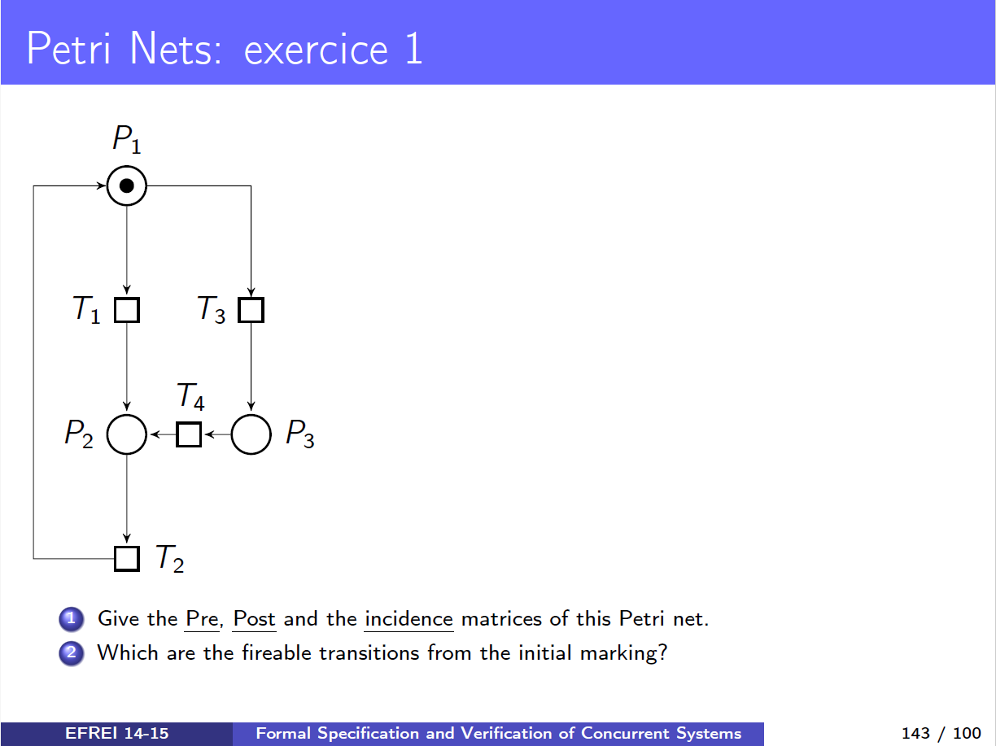

Question 1.1) The PRE matrice
 | T1 | T2 | T3 | T4
P1 | 1 | 0 | 1 | 0
P2 | 0 | 1 | 0 | 0
P3 | 0 | 0 | 0 | 1

The PRE matrice defines the arcs that Goes = Places to the transistions

Question 1.2) The POST matrice
 | T1 | T2 | T3 | T4
P1 | 0 | 1 | 0 | 0
P2 | 1 | 0 | 0 | 1
P3 | 0 | 0 | 1 | 0

The POST matrice defines the arcs taht Goes = Transitions to the Places

Question 1.3) The incidence matrice C
 | T1 | T2 | T3 | T4
P1 | -1 | 1 | -1 | 0
P2 | 1 | -1 | 0 | 1
P3 | 0 | 0 | 1 | -1

The Incidence matrice is defined by

[ -1 ] → Pn vers Tn (sortante); [ 1 ]→ Tn vers Pn (entrante);

Question 2) Which are the fireable transitions from the initial marking ?
T1 and T3 are the two fireable transitions from the initial marking because m(P1) = 1.

